**Client-Side-Coding Practice Lab- Parth Gosar**

1. Working with DOM Page Objects accessible in JavaScript

File DOM Objects in JavaScript attached.

The property navigator.appName returns the name of the browser. Here, "Netscape" is the name of a web browser.

The property navigator.appVersion returns a string containing the version information of the browser. It includes details about the operating system and the specific browser versions.

The property navigator.cookieEnabled returns a Boolean value indicating whether cookies are enabled in the browser.

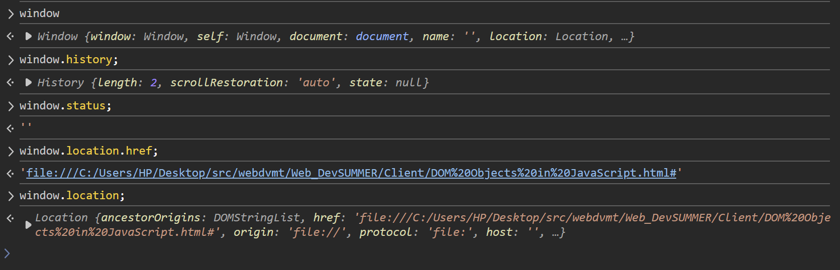

The property on the window object that returns the current URL of the displayed web-page is window.location.href.The window.location.href property is part of the window.location object, which provides information about the current URL of the document loaded in the browser window. This property specifically returns the full URL of the current page as a string.

**NOTE: Number 3 is not included since there is nothing specifically assigned for the part.**

1. Creating & Using JavaScript Functions

File Index attached

1. JavaScript Object Notation / JSON

File jason_3_1 attached

File JSON Reviver Function attached



1. Extending and customizing JSON output
2. File part1 attached

Output on Console:

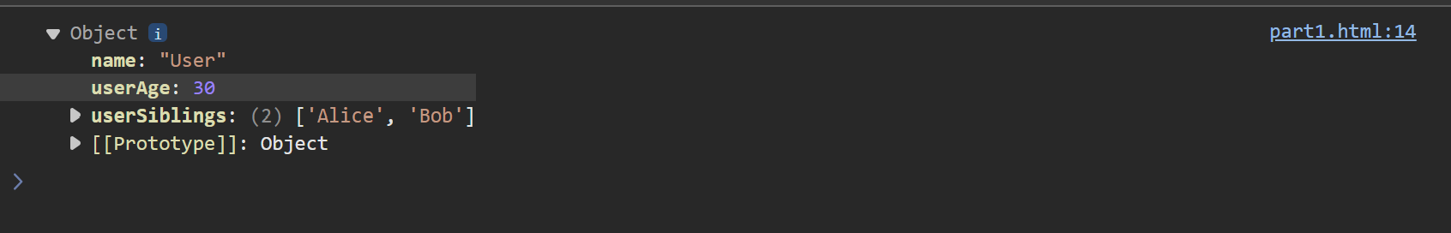

1. File part2 attached.

Output on Console:

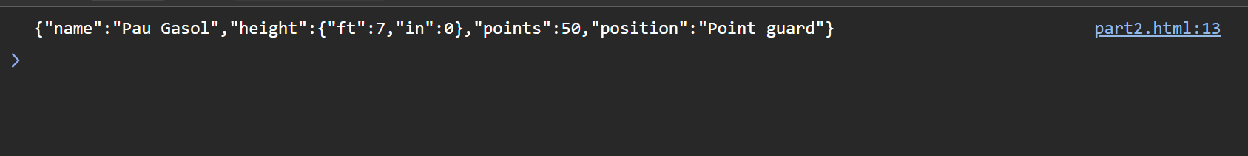

1. File part3 attached.

Output on Console:

1. File part4 attached.

Output on Console:

1. File part5 attached.

Output on Console:

